

**Question #01**

**Input, Processing and Output Chart**

|  |  |  |
| --- | --- | --- |
| Input | Processing | Output |
| First number  Second Number | Addition  Subtraction  Multiplication  Division | Sum  Difference  Product  Ratio |

**Scratch Design and Structure**

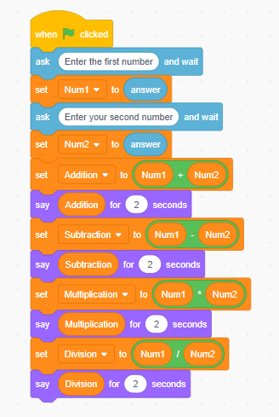

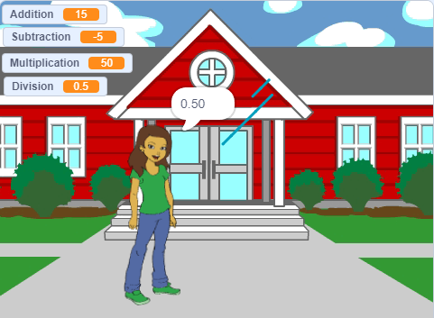

**Question #02**

**Input, Processing and Output Chart**

|  |  |  |
| --- | --- | --- |
| Input | Processing | Output |
| Length = 40 cm  Height = 25 cm  Width = 18 cm | Multiplication | Volume |

**Scratch Design and Structure**

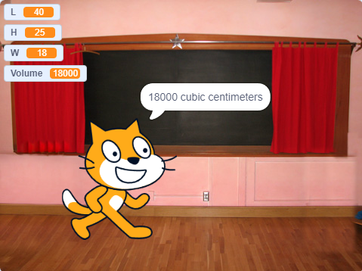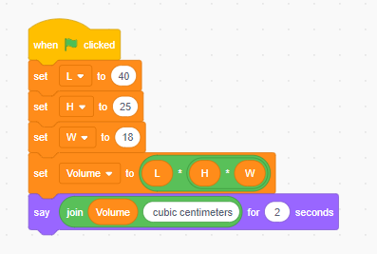

**Question #03**

**Input, Processing and Output Chart**

|  |  |  |
| --- | --- | --- |
| Input | Processing | Output |
| Length (Base) Height (Perpendicular) | Solving with the help of Pythagoras theorem | Diagonal distance (Hypotenuse) |

**Scratch Design and Structure**

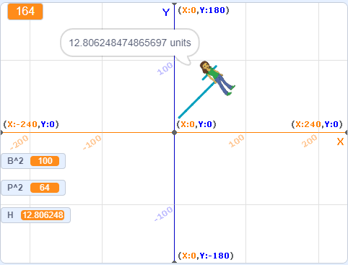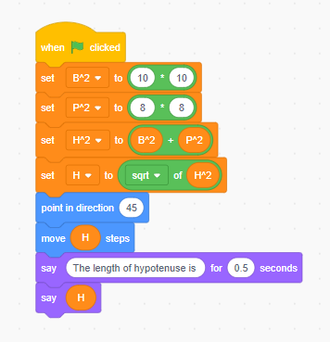

**Question #04**

**Input, Processing and Output Chart**

|  |  |  |
| --- | --- | --- |
| Input | Processing | Output |
| Distance from Hometown to South  Distance from South to West  Distance from West to South  Distance from South to North | Sum of distance Mean of fuel consumption | Total Distance  Fuel Consumed |

**Scratch Design and Structure**

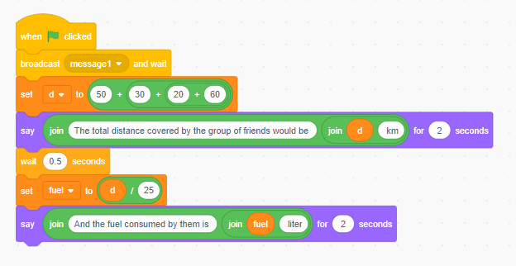

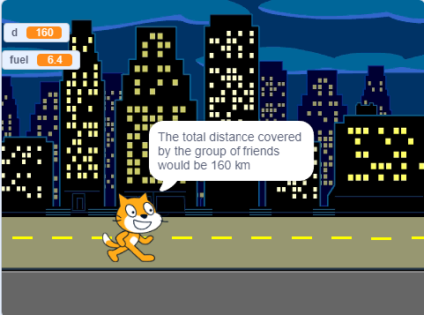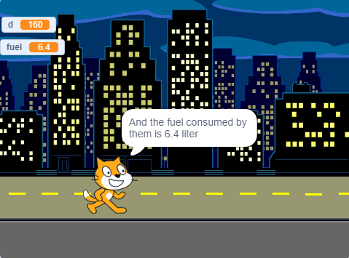

**Question #05**

**Input, Processing and Output Chart**

|  |  |  |
| --- | --- | --- |
| Input | Processing | Output |
| Length of triangular field  Height of triangular field | Multiplication of length and height divided by 2 | Area of the triangular field |

**Scratch Design and Structure**

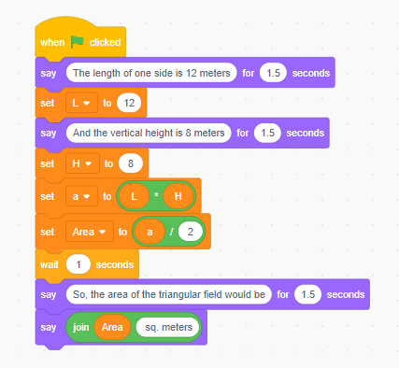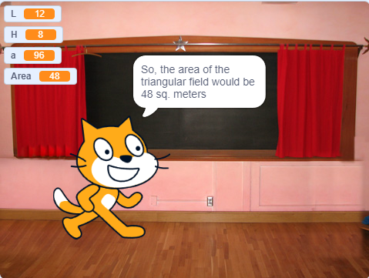

**Question #06**

**Input, Processing and Output Chart**

|  |  |  |
| --- | --- | --- |
| Input | Processing | Output |
| Initial co-ordinates Final co-ordinates | Using distance formula | Distance between the given points |

**Scratch Design and Structure**

